**Tushar Patel**

**Senior Business Anlayst**

**+91 9998802567**

Intrinsically motivated and intellectually curious lifelong learner who is passionate about data analytics. Seeking opportunities where I can utilize and further develop my analytical, mathematical and technical skills to solve real life problems related to analyzing big volume datasets, to draw insights that can help with business decisions.

**Skills**

**Technical skills**

* **SQL** (Basic, Groupings, Filtering)
* **Excel** (VLOOKUP, Pivot Tables, Conditional Formatting)
* **Power BI** (Power Query, Power Pivot, DAX, data source connection, score card, visualization)

**Soft Skills**

* **Growth mindset**
* **Analytical & critical thinking**
* **Teamwork**
* **Perseverance**
* **Operation BAU**
* **Production Management**
* **Quality**
* **Communication skills** *(Excellent to very good verbal and written skills in 3 languages: English, Hindi, Gujarati*

**Certifications**

* **Simpilearn** - Sep. 2020 **Edureka** - Aug. 2020

Data Science Specialization Power Bi Business Analytics

**Course**

* Data Analysis with Python
* SQL Basic
* Data Analysis with Excel
* Data Analysis PowerBi

**Power BI Project:**

**LinkedIn Data Project (data source connection, DAX, score card, visualization)**

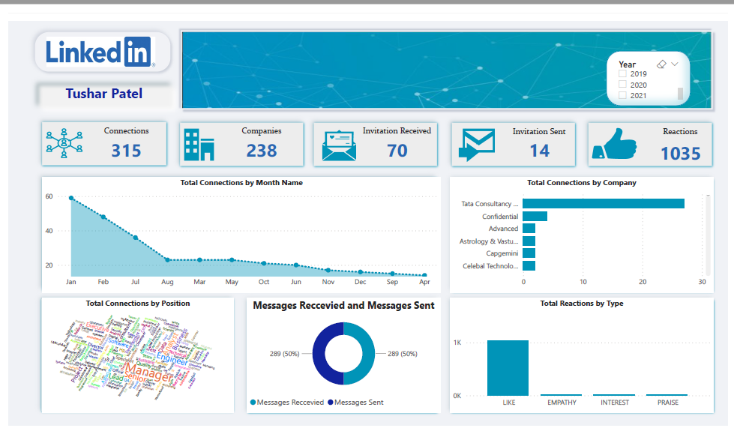

**HR Training dash board (data source connection, DAX, score card, visualization)**

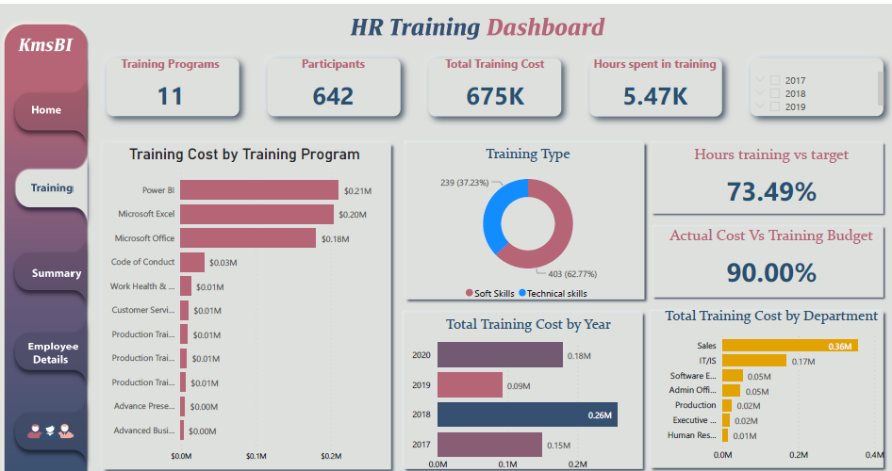

**Avocado Price analytic dash board (data source connection, DAX, score card, visualization)**

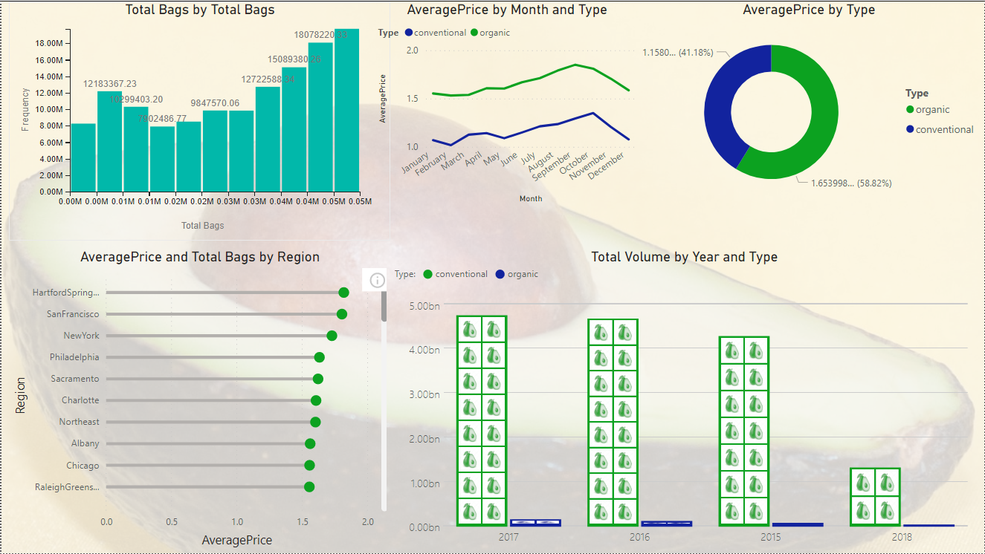

**Covid Vaccination Process case study (data source connection, DAX, score card, visualization)**

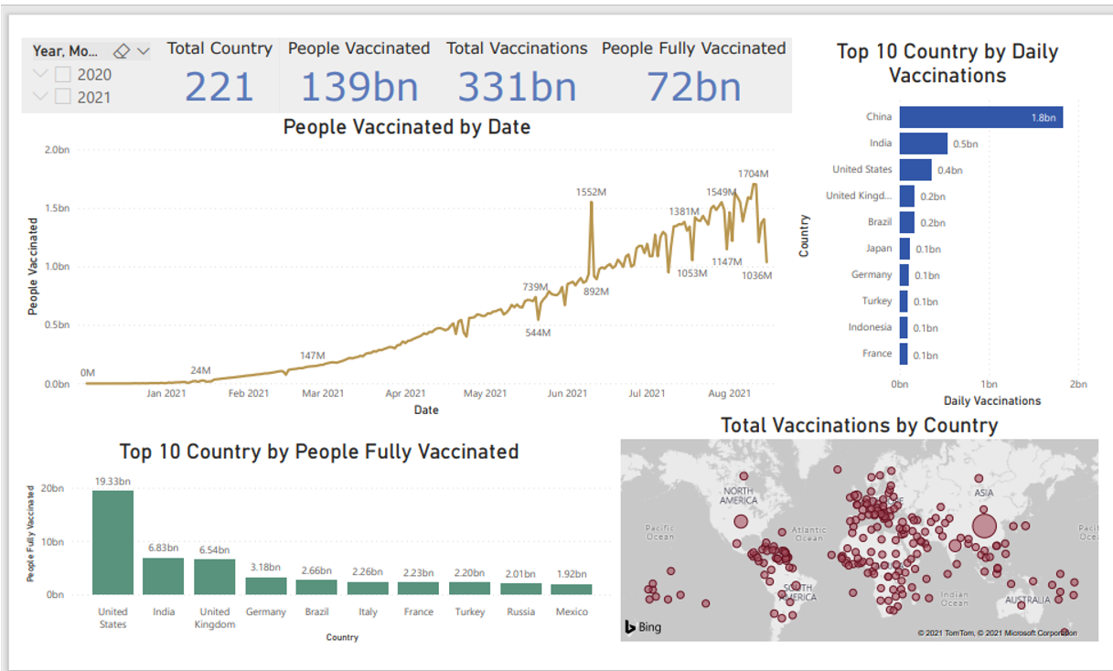

**Key Responsibilities:**

**Client Name: Citi Bank NA USA** **July 2016 to till date**

**Designation: Senior Business Analyst**

**Complaint Management│Mortgage│Card Management │**

* Monitor and send daily production emails with quality/production tips, current production challenges, plans to maintain Service Level Agreements, etc.
* Motivate and lead team to success using recognition, team building activities and positive reinforcement
* Set and manage to production and quality expectations
* Pipeline Management to ensure SLA metrics are met each day and loan assignment is compliant with licensing requirements
* One-on-One mentoring, weekly or as needed, for team members who are not meeting the production and/or quality expectations (inform Unit Manager of any recurring performance issues, develop action plans to address)
* Document all One-on-One coaching sessions to identify and track improvement
* Hold daily/weekly huddles to discuss results from previous days, changes, etc.
* Function as a SME and lend assistance for questions and scenarios

**Key Responsibilities:**

**Client Name: Nielsen INC. USA Market research Oct 2008 to June 2016**

**Designation: Senior business Analyst**

* Background in digital project management working on campaigns from initial briefing to delivery
* Evidence of working with MR project management methodologies
* Multi-tasker with ability to juggle many projects
* Agency experience with strong communication skills, both written and verbal
* Passion for IT, e-commerce and digital projects
* Creative flair and innovative approach
* Proven experience of effectively managing large-scale projects from brief through to delivery
* Adept at building effective client relationships and working with several stakeholders to deliver targets
* Experienced in a range of project management software including Nitro, Adviser, Answer desktop, and Nielsen Answer portal and Client FTP for client related changes.
* Strong communication with excellent presentation, report writing and data analysis capabilities
* Ability to work under pressure, change direction when required and work on a range of client projects at the same time
* Experience of identifying business opportunities, building client relationships and seeking new business
* Project mainly Hypermarket and Supermarket is reported for France, Argentina, Brazil, Italy, Portugal, Spain and Turkey country
* Ah old and DANONE clients are excel, power point and word template based project
* Prepare the process related document like SOP (process map), JOB Aid and hierarchy.
* Creating Detailed Documents Report Specifications and Print Specification.
* Preparing different reports for Clients like: Signoff report, Root Cause Analysis Report, MIS, MOM, Improvement Ideas, Resource utilization etc.
* Identifying areas for automation and implement same on process.
* Working with the macro development team to complete the automation task.
* Preparing reports with a view to monitor the performance & efficiency of team members, ensuring compliance with pre-set quality parameters.

**Key Responsibilities:**

**Company Name: P S Software Pvt ltd Jun 2005 - Sep 2008**

**Designation: Accountant Executive**

* Reporting to head office day to day, collected new employees’ information and updated in server, government statutory accounts, employee salary, PF & ESI
* Prepared and previewed final financial statements and periodic reports to management
* Provided back-up and supported the Payroll Process invoices form payment
* Maintained general ledger and journal entries
* Consolidated three branches for Profit and Loss Process and checked payments to the vendors
* Prepared financial reports, including Profit and Loss Statement, Balance Sheet and Statement of Cash
* Flows Preparation of all financial reports, including Profit and Loss Statement, Balance Sheet and Statement of Cash Flows Process invoices, payments from customers and accounts receivable
* Researched and reconciled bank statements.

**Key Responsibilities:**

**Company Name: Umesh Enterprise, July 2003 - May 2005**

**Designation: Accountant Assistant**

* Maintained Sales- Purchase Ledgers, Journal ledger; end of bank reconciliation; Entered expense cash and debit vouchers entry and bank entry Data entry in Tally 7.2 system

**Academic Credential**

* B Com in Accounting and auditing from Gujarat university 2002-03

**Personal Profile**

* Date of Birth : 05/05/1978
* Permanent Address: C/1/1 GIDC Colony Makarpura Road Baroda, Gujarat, India
* Language : English and Hindi, Gujarati